Demand and Inventory Forecasting Solution — Apparel Retail

Executive Summary
Over the last quarter, approximately 5.3% of store-category-weeks experienced inventory stockouts. By forecasting demand and simulating inventory for the next 13 weeks, our predicted store level demand plan projects stockout risk dropping from 5.3% to 0.77%, effectively reducing potential lost sales exposure by over 85%.
Categories including Accessories, Jackets, Shirts, and Trousers are expected to maintain sufficient inventory. Dresses require targeted replenishment attention due to a forecasted stockout of 3.08%.
For a high-level view of expected demand by zone and category over the next 13 weeks, refer to the Zone × Category Forecast Heatmap in Appendix F.

Understanding the Business Challenge
Effective inventory management is a critical driver of retail performance. Stockouts lead to lost revenue, dissatisfied customers, and inefficient replenishment cycles. In a network spanning multiple stores and categories, anticipating demand and aligning inventory proactively is essential for operational excellence. Historical data showed ~5.3% stockouts across all our stores and categories. Our goal is to bridge this opportunity by providing leadership with a reliable, forward-looking view of zone and store-category level demand planning to reduce stockouts to below 1%.

What did we build
We developed an integrated demand and inventory forecasting framework that combines sales, inventory, and calendar signals into a unified planning model.
Key differentiators:
Granular Forecasting: Demand is predicted at the store × category × week level, capturing both local store variations and category-specific trends.
Inventory-Aware Modeling: We simulate future stock positions by combining forecasted demand with historical replenishment patterns, reflecting real-world inventory dynamics rather than assuming static stock levels.
Data-Driven Accuracy: Based on historical forecast performance, weekly demand per zone-category is expected within approximately ±9 units of actual demand, giving leadership an accurate and measurable view of forecast reliability.

Results and Business Impact
Our analysis shows that historical stockouts occurred in approximately 5.3% of store-category-week observations over the last quarter (13 weeks). By forecasting demand and simulating inventory levels, the next 13-week horizon projects stockout risk dropping to 0.77%, effectively reducing potential lost sales exposure by over 85%.
Category-specific insights reveal that:
- Categories, including Accessories, Jackets, Shirts, and Trousers, are expected to maintain sufficient inventory, with 0 stockout risk.
- Dresses exhibit minor stockout risk (3.08%), warranting targeted replenishment focus.
This provides leadership with high confidence to optimize inventory allocation, plan promotions, and ensure high service levels across all stores.

Why Leadership Can Trust This Approach
Numeric Confidence: Forecasts are aligned with historical patterns and current operational dynamics, with weekly demand predicted within ±9 units of actual values at a zone level.
Operational Alignment: Analysis of historical replenishment patterns shows that 50% of weekly store-category records include stock additions, reflecting realistic inventory behavior rather than theoretical assumptions.

Business Recommendation
Allocate inventory by forecast intensity: Use the Zone × Category Forecast (Appendix F) as the primary allocation map: route more inventory to zones and categories with the largest 13-week demand totals, and scale back allocation where forecast intensity is low.
Use the Store × Category Forecast (Appendix G) as a secondary allocation map. This ensures granular, top-down inventory allocation at the store level within each zone, streamlining operational decisions consistently across zones and stores.
Prioritize replenishment for at-risk categories and reduce excess for stable categories: For categories with forecasted stockout risk (e.g., Dresses — 3.08%), increase reorder frequency (every 6 weeks) and safety stock at the store and zone level to prevent lost sales. For stable, low-risk categories (Accessories, Jackets, Shirts, Trousers), adopt tighter buffers (every 13 weeks) to free up working capital and reduce markdown exposure.
Store managers should use the store-level forecasts (Appendix G) to set specific reorder points and transfer plans.
Operationalize forecasts inside planning workflows. Integrate weekly 13-week forecast exports into the store operations dashboard used by procurement and store operations so decisions are made from the same, up-to-date demand signal. Implement a weekly review cadence where forecasts are compared to actuals and replenishment actions are decided (reorders, transfers, or promotion adjustments) based on those comparisons.
Note: While forecasts are robust at the aggregate (zone) level, store-level replenishment should include a small operational buffer for low-volume or volatile categories to account for short-term variability and localized risk.

Appendix: Detailed Approach and Modeling Insights

Appendix A — Forecasting Framework Overview
The demand and inventory forecasting solution operates in two stages to ensure accurate and actionable store-level forecasts:
- Zone-Level Demand Forecasting: Weekly demand is first predicted at the zone × category level using a LightGBM model. This model incorporates historical sales, inventory trends, and calendar-based features such as promotions and festivals.
- Store-Level Allocation: Zone-level forecasts are distributed to individual stores using a Ridge Regression model. This regression predicts the share of zone demand each store is expected to fulfill based on historical store contribution to the zone’s total sales. The Ridge Regression model achieves an R² of approximately 0.92 on historical allocation patterns, ensuring store-level forecasts reflect operational reality.
This two-stage approach balances granularity with consistency: stores receive forecasts aligned with local demand patterns, while overall zone totals remain accurate.

Appendix B — Key Features Used in Forecasting

Feature Group | Description | Example Features
Historical Sales | Captures recent trends and seasonal shifts | Lag 1–12 weeks, rolling 4–12 week averages
Inventory Metrics | Provides inventory-aware adjustments | Past stock levels, stockouts, average replenishment quantity
Calendar & Temporal | Accounts for temporal demand variations | Week of year, month, year, festival, promotion, weekend flags
Aggregate Zone & Category | Captures relative demand within zones and categories | Zone-week total, category-week total, store share of zone
Store Attributes | Reflects capacity and traffic differences | Average store size, average footfall

Appendix C — Model Choice and Training
- LightGBM: Handles non-linear feature interactions efficiently while allowing interpretability through feature importance.
- Training Setup: Trained on historical store × category weekly sales with early stopping on validation data to prevent overfitting.
- Performance Metrics: Validation MAE of 8.89 units and RMSE of 19.79 units indicates weekly demand predictions are within a reasonable operational margin.

Appendix D — Feature Importance

Feature | Importance Score | Notes
share_of_zone_prev | 2731 | Indicates previous contribution of store to zone
zone_week_total | 1804 | Total sales in the zone for the week
roll_8w_std | 766 | Sales variability over 8-week rolling window
cat_week_total | 647 | Total category sales for the week
roll_4w, roll_8w, roll_12w | 615–480 | Rolling averages capture short- and medium-term trends
Lag features (1–12 weeks) | 433–319 | Recent historical sales
cat_code, zone_code | 181 | Category and zone identifiers
avg_store_size, avg_footfall | 62–122 | Store-specific capacity and traffic
is_promo_week, year, month | 12–51 | Calendar and promotion effects

Appendix E — Store Allocation and Forecast Accuracy

Aspect | Description
Store Allocation | Ridge Regression predicts each store’s share of zone-level forecast using historical contribution
R² Accuracy | ~0.92, indicating high alignment with historical allocation patterns
Forecast Accuracy Metrics | LightGBM validation: MAE = 8.89 units/week, RMSE = 19.79 units/week
Operational Insight | Framework allows visualization of store-level forecasts, key drivers, and inventory-adjusted demand

Appendix F – Forecast Heatmap — Zone × Category Overview

This heatmap shows the predicted total units per category across all zones for the next 13 weeks, providing leadership a quick view of expected demand intensity and inventory planning priorities.

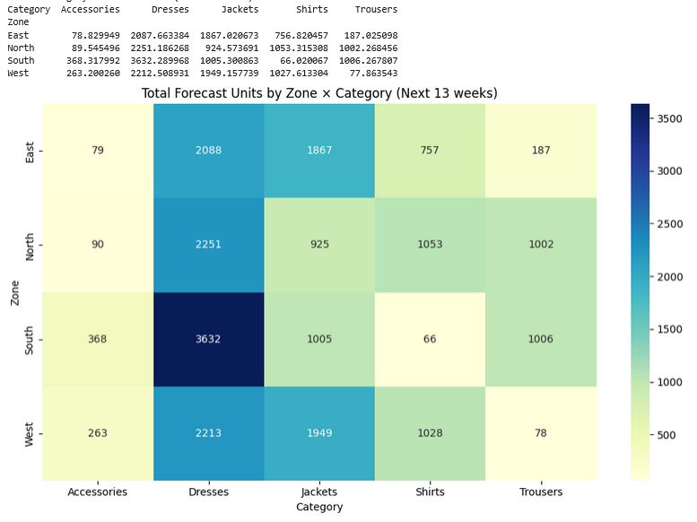

Appendix G –Detailed Zone & Store level Forecasts

The following files in the ZIP folder contain the detailed weekly forecasts for granular planning:
zone_category_forecast_13_weeks: Shows zone *category * week level forecasts.
store_category_forecast_13_weeks_reconciled: Shows reconciled/distributed store * category * week level forecasts.
Additional files in the folder for reference:
forecasted_stockouts_store_category_week: Shows forecasted stockouts used for result estimation.

